
Cairo University
Faculty of Computers and Artificial Intelligent

CS251 - Software Engineering I

Project Name
Software Requirements Specifications (SRS)

Team Names

Month & Year
Contents
Instructions [To be removed] 3
Team 3
Document Purpose and Audience 3
Introduction 3
Software Purpose 3
Software Scope 3
Definitions, acronyms, and abbreviations 3
Requirements 4
Functional Requirements 4
Non Functional Requirements 4
System Models 4
Use Case Model 4
Use Case Tables 5
Requirements Traceability matrix 6
Ownership Report 6
Policy Regarding Plagiarism: 6

Team
ID | Name | Email | Mobile
20240519 | Mohamed Alaa Ahmed | 20240519@stud.fci-cu.edu.eg | 01156323478
20240318 | Abd El-Rahman Waheed | 20240318@stud.fci-cu.edu.eg | 01033779086
20231139 | Mohamed Hussein Goma | 20231139@stud.fci-cu.edu.eg | 01128466440
20220023 | Ahmed Tolba Mohamed | 11410120220023@stud.cu.edu.eg | 01112097273

Document Purpose and Audience

1. Document Purpose and Audience
What is this document?
- This document specifies the requirements for the Campus Connect student community social media platform.

- It describes the functional and non-functional requirements, user interactions, and system constraints to guide design and implementation.
Target Audience:
Role / Audience | Purpose for Reading
CEO | Understand overall purpose, business value, and strategic importance of the system.
Project Manager | Verify that requirements are complete, consistent, and correct; provide feedback on project progress.
Development Team | Guide system design, coding, and testing.
System Managers | Understand system features related to administration and moderation.
Customers | Optional: high-level overview to understand platform capabilities and interactions.

Introduction

Software Purpose
- Campus Connect is a social media platform designed specifically for university students.
- Purpose:
  - Help students connect with peers in their courses and departments.
  - Enable sharing of academic resources and collaboration on projects.
  - Provide community and event features tailored to campus life.
  - Offer secure authentication and moderation tools for administrators.

Software Scope
Major features included in the implementation:
- User Management & Authentication
  - Student ID-based registration and login
  - Profile creation and management
  - Secure password encryption
- Friendship Management
  - Send, accept, reject, delete, or block friends
- Post & Feed Management
  - Create posts (text, images, video, links)
  - Visibility settings (public, friends-only, communities)
  - Personalized feeds: time-ordered & relevance-based

- Community & Group Management
  - Create/join interest-based communities
  - Post within communities
- Event Management
  - Create events with full details
  - RSVP and event discovery
- Messaging System
  - Direct one-on-one messages
  - Group chats
- Notification System
  - Notify users of messages, friend requests, and post interactions
- Administrative & Moderation Functions
  - Report inappropriate content
  - Admin moderation & user banning
Scope exclusions (not in this phase):
- Advanced AI-based recommendation algorithms
- Third-party integrations (like Google Calendar or Zoom)
- Mobile app version (focus on web platform)

Definitions, acronyms, and abbreviations
Term / Acronym | Definition / Explanation
SRS | Software Requirements Specification
TA | Teaching Assistant
MVC | Model-View-Controller software architecture
SOLID | Set of object-oriented design principles: Single responsibility, Open-closed, Liskov substitution, Interface segregation, Dependency inversion
RSVP | “Répondez s’il vous plaît” – Response options for event attendance (Going, Interested, Not Going)
ID | Identification number
UI | User Interface
DB | Database

Requirements

Functional Requirements
- The system shall allow users to register using university email and student ID.
- The system shall verify that the email belongs to the university domain (e.g., @stud.fci-cu.edu.eg).
- The system shall hash passwords using a secure hashing algorithm (e.g., bcrypt).
- The system shall prevent duplicate registration using the same student ID or email.
- The system shall allow users to log in using email and password.
- The system shall compare the hashed input password with the stored hash before granting access.
- The system shall lock the account for a short period after multiple failed login attempts.
- The system shall allow users to create and update their personal profile.
- The system shall allow users to send, accept, reject, and delete friend requests.
- The system shall allow users to create and view posts containing text, images, or links.
- The system shall allow users to set post visibility (public, friends-only, or community-specific).
- The system shall allow users to create and join interest-based communities.
- The system shall allow users to create and view campus events with title, description, location, and date/time.
- The system shall allow users to RSVP to events with options such as Going, Interested, or Not Going.
- The system shall allow administrators to review reported content and ban or delete users.
- The system shall validate that all required fields are filled during registration.
- The system shall send a confirmation message when an account is successfully created.
- The system shall allow users to reset their password through email verification.
- The system shall allow users to delete their own posts.
- The system shall display the main feed by showing posts sorted by most recent first.
- The system shall allow users to report posts or users for inappropriate behavior.
- The system shall notify users when they receive a friend request.
- The system shall notify users when they receive an event invitation or reminder.
- The system shall only allow logged-in users to create posts, join communities, or interact.
- The system shall log all admin actions (banning, deleting content) for auditing.

Non Functional Requirements
Type | Requirement
Performance | The system shall respond to user actions within 2 seconds under normal load
Security
  All passwords and sensitive data shall be encrypted, and the system shall use role-based access control for users and administrators
Usability | The interface shall be simple and intuitive, with clear navigation and error messages
Maintainability | The system shall follow SOLID design principles and MVC architecture for easy updates
 | The system should function correctly on major web browsers (Chrome, Edge, Firefox)
  Compatibility

System Models

Use Case Model
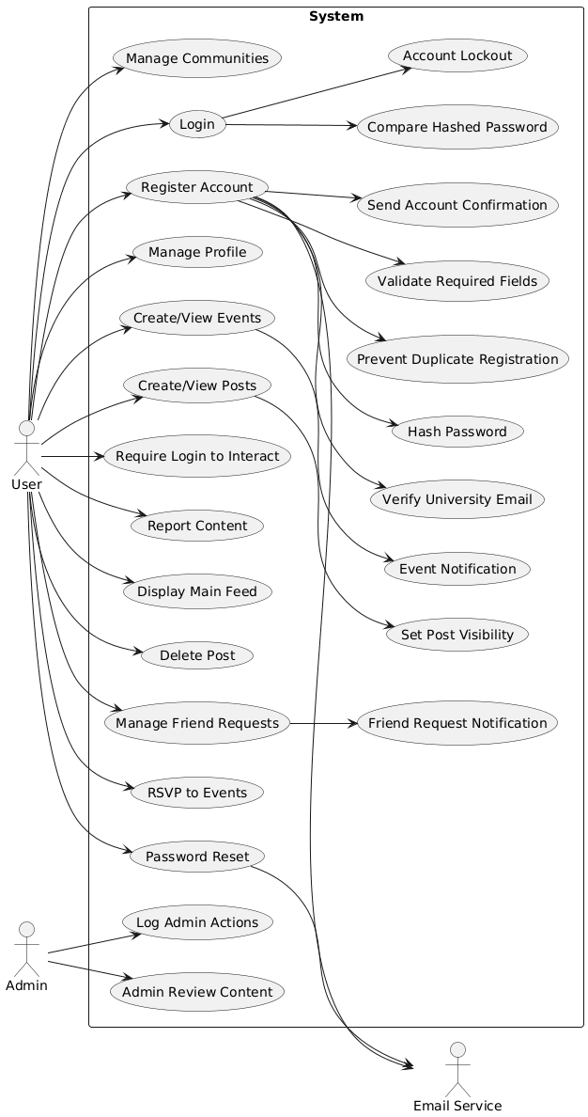

Use Case Tables

Use Case 1 — Register Account
Item | Description
Actors | User
Preconditions | User is not registered
Main Flow | 1. User enters email, student ID, password.  2. System validates required fields.  3. System verifies university email domain.  4. System checks for duplicates (email/student ID).  5. System hashes password.  6. System creates account.  7. System sends confirmation message.
Postconditions | Account is created. User receives confirmation.

Use Case 2 — Login
Item | Description
Actors | User
Preconditions | User has a registered account
Main Flow | 1. User enters credentials.  2. System compares hashed password.  3. If incorrect multiple times → lock account.
Postconditions | User is logged in.

Use Case 3 — Manage Profile
Item | Description
Actors | User
Preconditions | User logged in
Main Flow | User updates or edits personal profile.
Postconditions | Profile updated.

Use Case 4 — Manage Friend Requests
Item | Description
Actors | User
Preconditions | User logged in
Main Flow | Users send, accept, reject, delete friend requests.
Postconditions | Updated friend relationships. Notifications sent.

Use Case 5 — Create / View Posts
Item | Description
Actors | User
Preconditions | User logged in
Main Flow | 1. User creates post (text/img/link).  2. User sets visibility.  3. User can view posts.
Postconditions | Post visible to allowed audience.

Use Case 6 — Delete Post
Item | Description
Actors | User
Preconditions | User owns the post
Main Flow | User deletes their own post.
Postconditions | Post removed.

Use Case 7 — Display Main Feed
Item | Description
Actors | User
Main Flow | System displays posts sorted by newest first.

Use Case 8 — Manage Communities
Item | Description
Actors | User
Preconditions | User logged in
Main Flow | User creates or joins interest-based communities.
Postconditions | Community membership updated.

Use Case 9 — Create / View Events
Item | Description
Actors | User
Preconditions | User logged in
Main Flow | User creates events or views campus events.
Postconditions | Events saved or displayed.

Use Case 10 — RSVP to Events
Item | Description
Actors | User
Preconditions | Event exists
Main Flow | User selects (Going / Interested / Not Going).
Postconditions | User’s RSVP stored. Notifications sent.

Use Case 11 — Report Content
Item | Description
Actors | User
Preconditions | User logged in
Main Flow | User reports content or users.
Postconditions | Admin receives report.

Use Case 12 — Password Reset
Item | Description
Actors | User
Preconditions | User has access to email
Main Flow | 1. User requests reset.  2. System sends verification email.
Postconditions | Password reset.

Use Case 13 — Admin Review Content
Item | Description
Actors | Admin
Preconditions | Admin logged in
Main Flow | Admin reviews reports, bans users, deletes content.
Postconditions | Actions logged.

Use Case 14 — Log Admin Actions
Item | Description
Actors | Admin
Main Flow | System logs every admin action.
Postconditions | Audit logs updated.

Requirements Traceability matrix

Functional Requirement ID Requirement Description Use Case ID / Name
FR1 Register new user with university email and student ID UC1 – Register New User
FR2 Login and password encryption UC2 – Login & Authentication
FR3 Edit user profile UC3 – Edit Profile
FR4 Manage friendships (send, accept, reject, delete) UC4 – Manage Friend Requests
FR5 Create multimedia posts UC5 – Create Post
FR6 Like and comment on posts UC6 – Interact with Posts
FR7 Create communities UC7 – Create Community
FR8 Join communities UC8 – Join Community
FR9 Create and manage events UC9 – Manage Events
FR10 Messaging system (direct and group) UC10 – Messaging
FR11 Notifications system UC11 – Notifications
FR12 Report inappropriate content UC12 – Report Content
FR13 Ban rule-violating users UC13 – User Ban

Ownership Report

Item | Owners
Document purpose | Mohamed Alaa
introduction | Mohamed Alaa
Functional Requirements | Abd El-Rahman Waheed
Non-Functional Requirements | Abd El-Rahman Waheed
Use Case diagram | Ahmed Tolba
Use Case Tables | Ahmed Tolba
Requirements Traceability Matrix | Mohamed Hussein
Ownership Report | Mohamed Hussein

Policy Regarding Plagiarism:

- تشجع الكلية على مناقشة الأفكار و تبادل المعلومات و مناقشات الطلاب حيث يعتبر هذا جوهريا لعملية تعليمية سليمة
- ساعد زملاءك على قدر ما تستطيع و حل لهم مشاكلهم فى الكود و لكن تبادل الحلول غير مقبول و يعتبر غشا.
- أى حل يتشابه مع أى حل آخر بدرجة تقطع بأنهما منقولان من نفس المصدر سيعتبر أن صاحبيهما قد قاما بالغش.
- قد توجد على النت برامج مشابهة لما نكتبه هنا أى نسخ من على النت يعتبر غشا يحاسب عليه صاحبه.
- إذا لم تكن متأكدا أن فعلا ما يعد غشا فلتسأل المعيد أو أستاذ المادة.
- فى حالة ثبوت الغش سيأخذ الطالب سالب درجة المسألة ، و فى حالة تكرار الغش سيرسب الطالب فى المقرر.

